A few videos back we installed the request-promise library. Before we test the endpoints that we just created, it might be necessary for you to also install the request library, depending on what version of the request-promise library you have.

**All students should do the following:**

To install the request library, simply go to your terminal, and inside of our blockchain directory run the command:

npm install request --save

You can see this in the photo below:

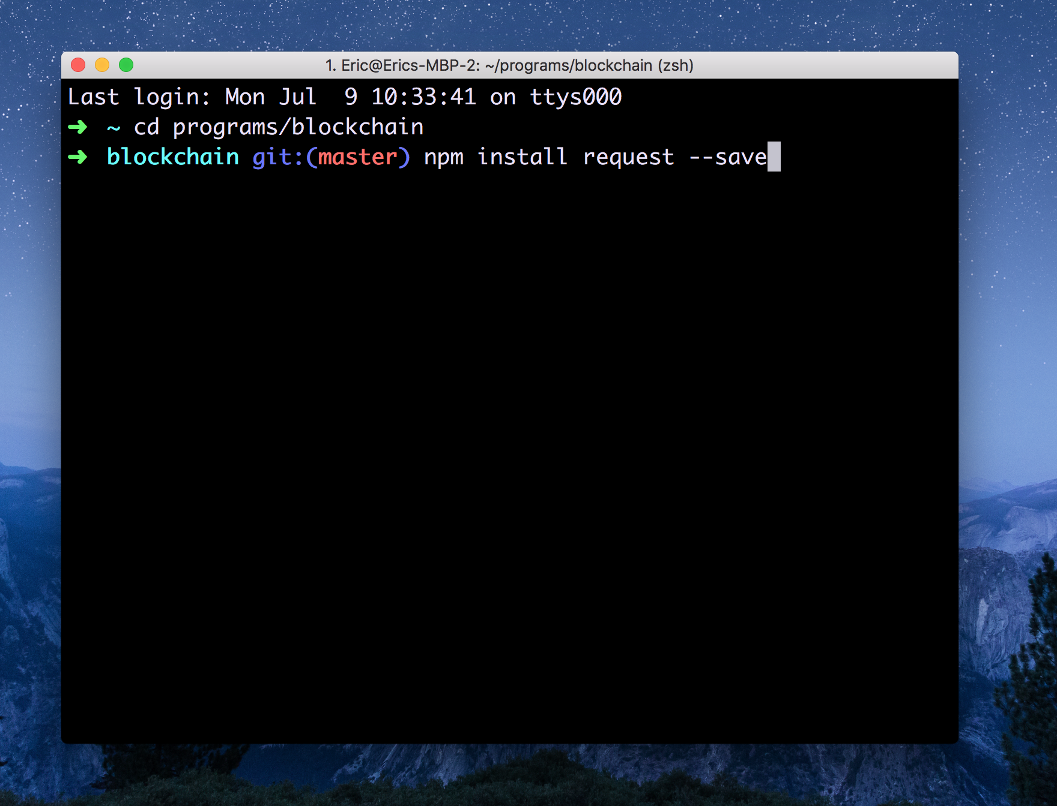

And that's it! I will see you in the next lesson where we will be testing our new endpoints!